NEW IN THIS UPDATE: the Commonwealth of Virginia; South East Queensland, Australia; Refined and Updated AAM/UAM Infrastructure Cost Assumptions, New ArcGIS Tools for Airspace Design, and A Personalized Approach to Aviation Planning

Urban Air Mobility -

Infrastructure and Global Markets
Detailed and Actionable Forecasts and ArcGIS Databases for
92 METROPOLITAN AREAS: 2023 – 2045
Market Intelligence and Analysis for OEMs, UATM and Vertiport Developers, AAM & Cargo Operators, cities, Regional and Federal Governments, and Investors
Our Clients Include:
The Government Accountability Office
Used our data in their 2023 AAM Report to the US Congress
https://www.gao.gov/products/gao-23-105188
The Commonwealth of Virginia
Commissioned us to prepare a statewide AAM analysis including economic impact.
https://www.virginiaipc.org/unmanned
Wisk Air Mobility
Our economic impact forecasts for South East Queensland, Australia begin on page 18:
https://wisk.aero/news/press-release/advanced-air-mobility-presents-opportunity-to-bring-economic-social-and-environmental-benefits-to-south-east-queensland/
NASA
Hired us to provide ArcGIS interactive maps of all ten facilities.
www.nexa-uam.com
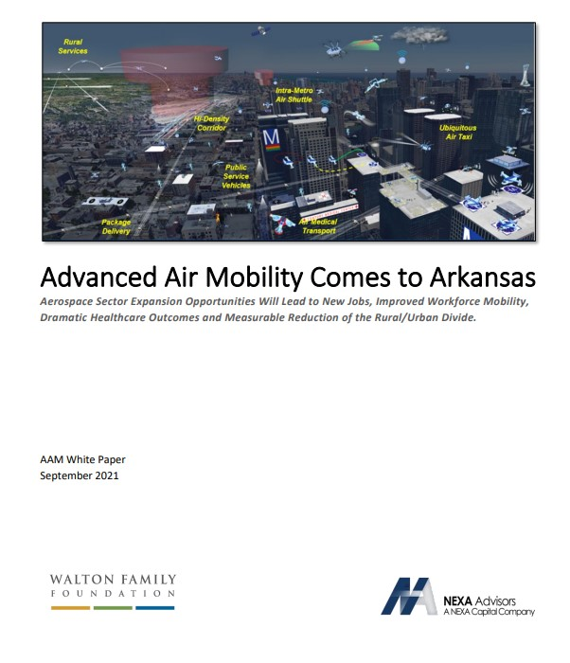
Arkansas
The Walton Family Foundation asked us to create a statewide economic impact analysis and examination of AAM use cases most helpful to a rural state.
www.nexa-uam.com

Ohio
We created a statewide AAM economic impact analysis for the Ohio Department of Transportation for passenger and cargo use cases.
https://nexacapital.com/reports-and-commentary

The Canadian Advanced Air Mobility Consortium
We analyzed AAM’s economic impact on the Vancouver region.
https://nexacapital.com/reports-and-commentary

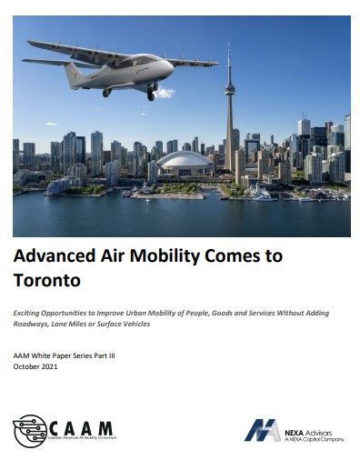
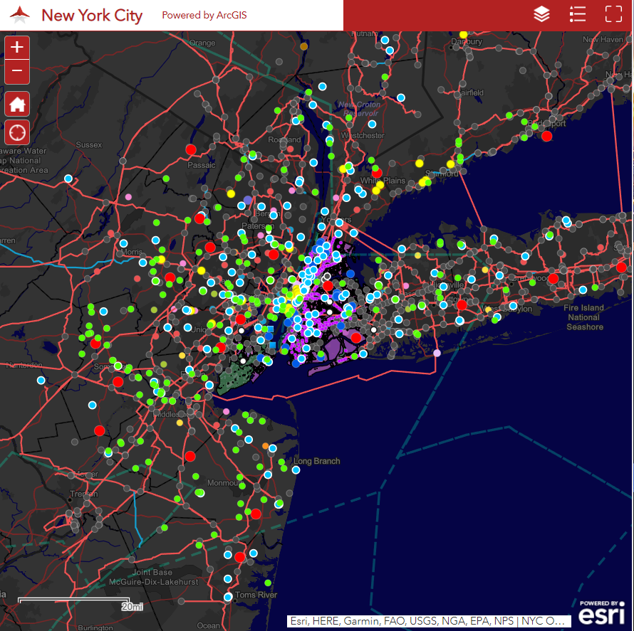
Urban Air Mobility: Infrastructure and Global Markets examines 92 cities and regions around the world and provides:
Interactive ArcGIS maps with more than 30 data layers including airports, heliports, hospitals, existing transportation modes, zoning, demographics, current power grid and substations, ports, major event venues, and much more.

- Cumulative UAM Passenger Demand Growth Analysis of each city from 2023 to 2045
- Ticket Prices
- Analysis of City Readiness vs. 23-Year Projected Passenger Revenues
- UAM Readiness Analysis for On Demand Air Taxi, Regional, Business Aviation, Emergency, and Airport Shuttle
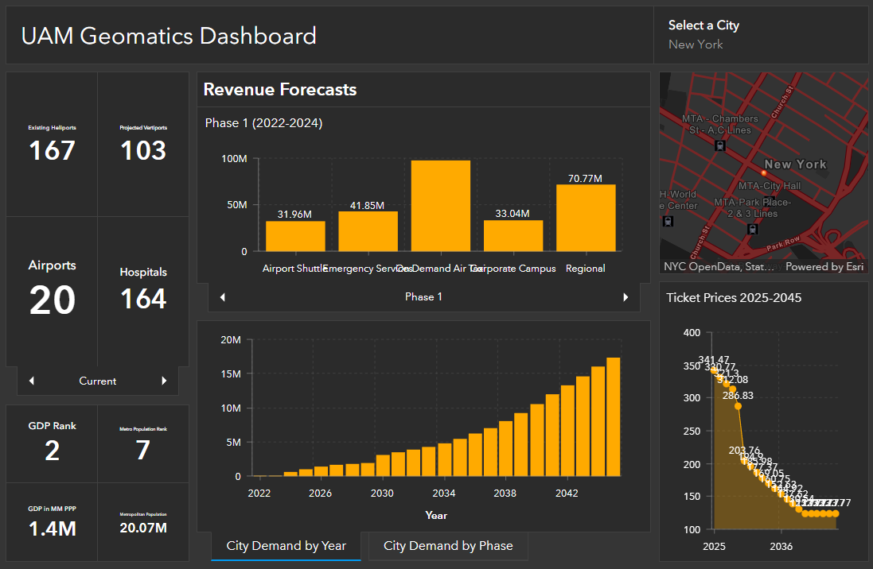
- Cumulative UAM Revenues, Market by Market Analysis for On Demand Air Taxi, Regional, Business Aviation, Emergency, and Airport Shuttle
- Total operator revenues
- Total infrastructure costs
- Total UAM traffic management costs
- Total estimated aircraft and fleet costs
- Business aviation presence
- Airport Originating and Departing Traffic
- Vertiport buildout timeline

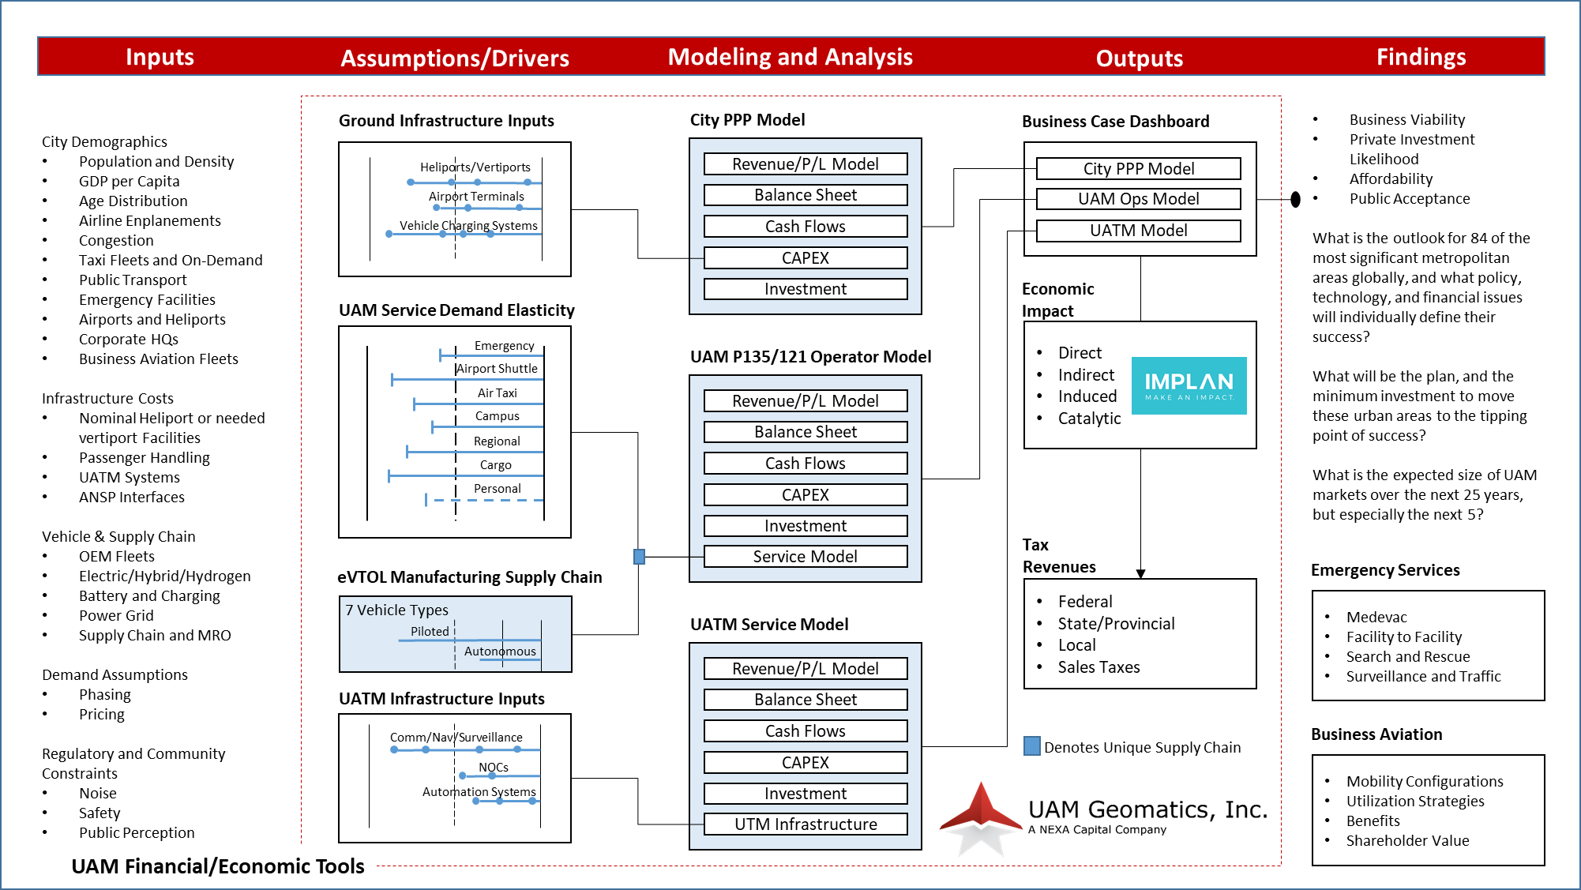
Our assumptions for modeling and analysis.

Our Global AAM Cities and Regions are:
Abu Dhabi | Amsterdam | Atlanta | Baltimore | Bangkok | Barcelona | Berlin | Bogota | Boston | Brussels
Buenos Aires | Charlotte | Chicago | Dallas | Denver | Detroit | Dubai | Geneva | Hamburg | Hong Kong
Houston | Istanbul | Jakarta | Kuala Lumpur | Las Vegas | Lima | London | Los Angeles | Madrid | Manila
Melbourne | Mexico City | Miami | Milan | Minneapolis | Montreal | Moscow | Mumbai | Munich | Nagoya
Nashville | New York | Ohio | Osaka | Paris | Philadelphia | Phoenix | Plovdiv | Portland | Raleigh
Reno | Rhine-Ruhr | Rio de Janeiro | Riyadh | Rome | San Diego | San Francisco | San Jose | Santiago | Sao Paulo
Seattle | Seoul | Singapore | Sydney | Syracuse | Taipei | Tampa | Tel Aviv | Tokyo | Toronto
Toulouse | Utah | Vancouver | Vienna | Virginia | Washington, DC | Wichita
If your company is interested in obtaining our data for a city not on the above list, please contact us.

What is the hottest topic in AAM right now?
Jobs, Jobs, and Jobs.
The technology has arrived. Now the industry needs legislative support and public acceptance.
For this reason, around the world, states, provinces, cities and even OEMs are commissioning AAM Economic Impact Analyses.
Figure 1 – Madison, Wisconsin State House.

Utilizing the data from our study, we are able to forecast a region’s new jobs, tax revenues, and overall economic productivity (direct, indirect, and induced) through 2045.
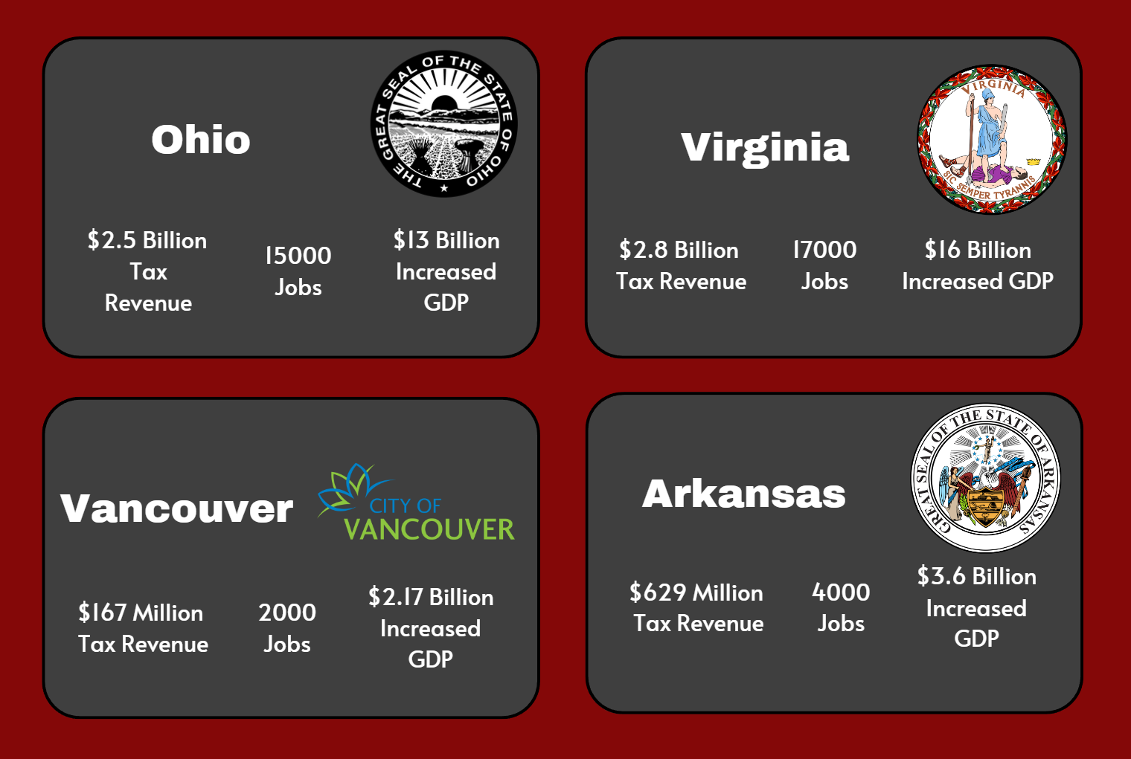

Below is a more detailed view of our work for the Commonwealth of Virginia.
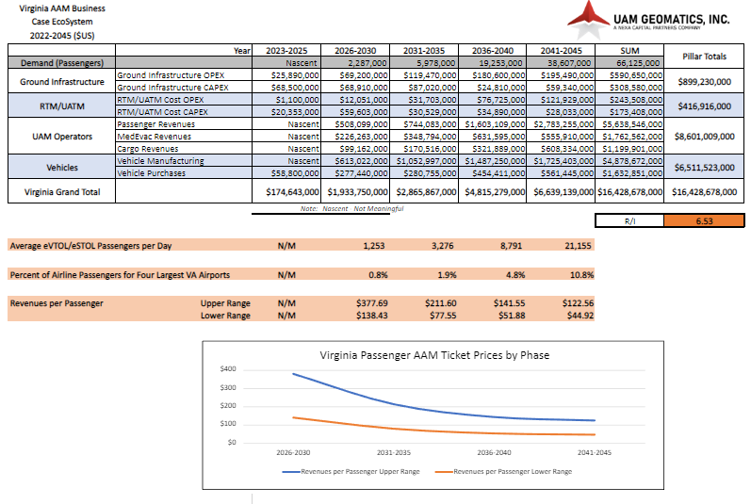

If your company is interested in an AAM economic impact analysis for a particular city or state, please contact us.

Price List

Package | Description | UAM Geo-  matics Final Report | UAM Geo-  matics Web Portal | Cities Profiled | City to City Benchmark- ing | Web App Map(s) | ArcGIS Geo- Coded Map(s) | Supply Chain Data Sets | High Resolu- tion Airport ArcGIS Maps | City P135 Op- erators | One-Time Fee ($US)
1 | Full Subscription - UAM Geomat- ics Economics Data and Toolset | Yes | Yes | 84 | Yes | Yes 84 | Yes 84 | Yes | Yes | Yes | $24,995.00
2 | Single City Subscription | Yes | No | 1 | No | Yes 1 | Yes 1 | Yes | Yes | Yes | $2,000.00
3 | Regular Updates for 60 Months |  |  |  |  |  |  |  |  |  | Included in  (1) Full Sub- scription.
4 | Economic Impact Studies of  Selected Metro Areas or Regions | Yes | Yes | 84 | Yes | Yes 84 | Yes 84 | Yes | Yes | Yes | Please contact us.

*Pricing subject to change without notice. For up-to-date pricing please contact a representative.

Subscription Agreement

Please submit pages 30-32 of this Subscriber Order Form, and carefully fill out following the instructions provided, and forward it to UAM Geomatics, Inc. as a pdf or jpg.

Full Subscriber  Identification: | For the UAM - Economics Data and Toolset Subscriber Edition chosen, please enter the company be-  low as a Subscriber. The Subscriber agrees to abide by the terms and conditions of the UAM Geomat- ics, Inc. Urban Air Mobility Data and Services Limited License, attached hereto.  Subscriber Company Name Address  City State/Province Country  Zip/Postal Code Telephone Email address
Authority: | On behalf of the Subscriber named above, I certify that I have read and accept the license agreement (page x) and have the authority to place an order for UAM Economics Data and Toolset.  Signature Name (printed)  Title Date Tel.
Payment: | ONE TIME SUBSCRIPTION: Select the package number on page 28 and write it here . Check the appropriate square for type of payment:  - check  - credit card  - wire transfer  In the amount of US$ .  UAM Geomatics, Inc. will issue a receipt upon acceptance of this Subscription and of payment. This one-time subscription provides the Subscriber with a five-year license and access to all quarterly report updates without further charge.  This annual subscription may be renewed upon the sole discretion of the Subscriber upon each anniversary, and includes, for each subscription year, an annual license and access to all quarterly report updates.  Each subscriber in entitled to five seats. Once payment has been received, we will grant the five participants you designate a password to access the website.

Confidentiality: ◻ We wish to have our company identity kept confidential as a subscriber to the UAM study.

Wiring United Bank Credit to: UAM Geomatics, Inc.
Instructions 1320 OId Chain Bridge Rd. Account #: 0087556391
McLean, VA 22101 ABA Routing #: 056004445
+1 (703) 356-2265 For non-US originating wires: //FW056004445

UAM GEOMATICS, Inc. Urban Air Mobility Data and Services Limited License

UAM Geomatics shall grant Subscriber and its Affiliates a limited, fair use, non-exclusive, revocable license ("Limited License") to use said UAM Geomatics information, data and services (collectively “UAM Geomatics Services”). Said Limited License shall be limited to employees and Affiliates of Subscriber to be used within the normal course of Subscriber’s business. Subscriber agrees that it shall not use UAM Geomatics' Services for any other purpose nor shall it permit any third party other than Affiliates to use UAM Geomatics' Services unless otherwise agreed in writing by UAM Geomatics. Subscriber agrees that it shall not publish, resell, transmit, broadcast, distribute, or otherwise use any of the UAM Geomatics’ Services in violation of this Agreement. Subscriber agrees that it shall not give access to the UAM Geomatics Services nor will it export UAM Geomatics’ data from nor import UAM Geo- matics’ data into any other forum, without written consent from UAM Geomatics. Subscriber agrees that it shall not use UAM Geomatics’ Services in any manner to compete with UAM GEOMATICS in UAM Geomatics' business or for any other purpose not permitted by this Limited License. We stand behind our products and your satisfaction with them is important to us. However, because our products are digital goods delivered via Internet, we offer no refunds.

For Further Information please contact:

Eleanor Herman
President
UAM Geomatics, Inc. Tel: 202-499-5056
Email: Eleanor.Herman@nexa-uam.com
Web: www.nexa-uam.com

